Ancient China on the Map

- Answer the questions underneath your map. Use your atlas or Google Maps, answer all the questions on the next page.

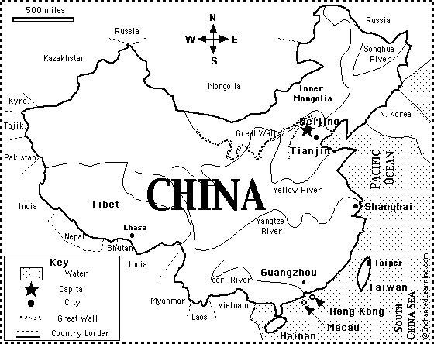

Questions

- Which continent is China in?
- What is the capital of China?
- What ocean borders China on the east?
- What sea is on China's southeast border?
- What river flows by Shanghai?
- Which major river crosses the Great Wall?
- In which part of China is its capital: NE, NW, SE, or SW?
- Name two countries that border China on the northeast.
- What is the name of the major river that flows by Shanghai?
- If you wanted to travel from Guangzhou to Shanghai, in which direction would you head?
- Roughly how many miles is it from Beijing to Shanghai: 6 miles, 60 miles, 600 miles, 6,000 miles, or 60,000 miles?
- There are 1.6 km in a mile. How many kms is your answer to Q10?
- Find a distance between two places in Australia that is roughly the same.
- Shade the map and the key above to make it more relevant and attractive.

