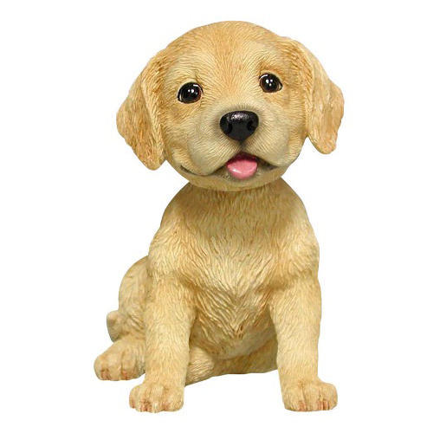
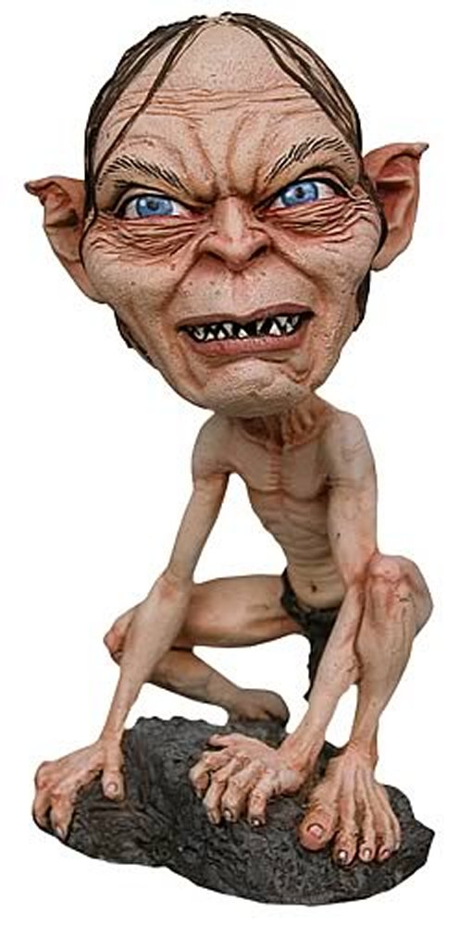
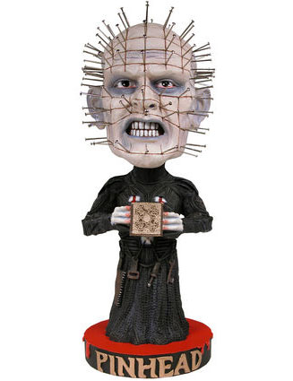
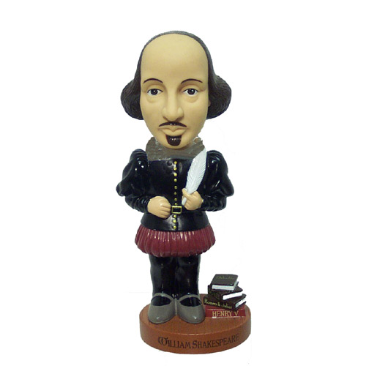
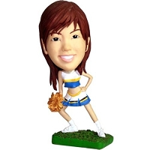
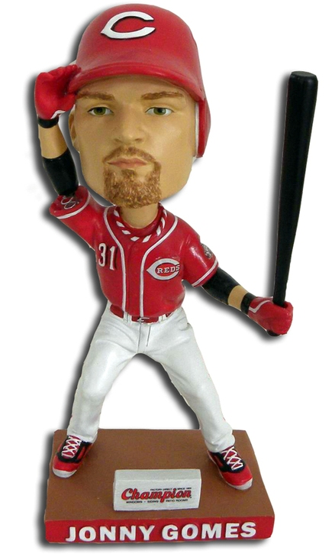
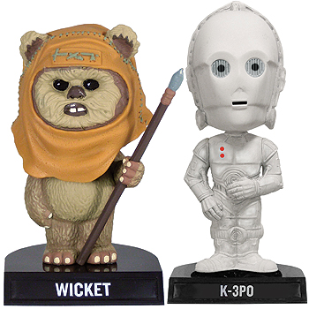
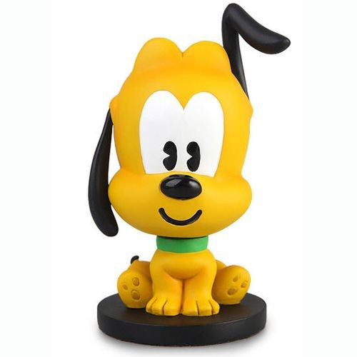
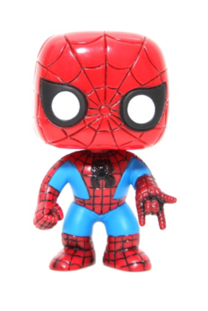

Project Evaluation Form

Name, Grade, Character Name: _______________________________________________
Project Title: Bobble-Heads
Student Teacher

Composition: / 10 /10
- Completion of jar activity shows hatching, carving and stamping?
- Completion of face activity shows attention to planes, detail, hollowing out and anatomy?
- Completion of initial planning of structure, shapes and structure?

- Work demonstrates a dedication of time and effort?
Technique: /10 /10
- Effective use of wedging and clay awareness?
- Effective hatching on of individual pieces?
- Effective use of carving and texture?
- Structure is sturdy and shows attention to base, hollowing and weight distribution?
- Overall skill development?
Presentation: /10 /10
- Work is clean (no bit and pieces crushed into clay)?
- Finishing touches: edges are clean, and smooth areas are smooth with no imperfections?
- Attention is paid to small details of the structure, pattern, texture, different levels?
- Paint is used cleanly and effectively (between the lines)?
Participation: /10 /10
- Use of class time?
- Attitude towards project?
- Skill development with respect to project?
- Willingness to make the effort to solve your own problems?
- Risk taking- being bold in your approach to your work?
- Clean up? Taking care of your space in the room?
Evaluation Total: /40 /40
Extra Comments:
