CHINA: THE BEGINNINGS

Read the information about the beginnings of Chinese civilisation.

China is one of the world’s oldest continuous civilisations. The area that is now China was inhabited by homo erectus (a relative of modern humans – we are called ‘homo sapiens’) more than one million years ago!

Stone tools found at Xiao Chang Liang in China have been dated to 1.36 million years ago; and the earliest recorded use of fire by homo erectus was 1.27 million years ago in Shanxi Province.

The most famous example of early Chinese inhabitation is the Peking Man, found in 1923. He has been dated to have lived between 250 000 and 400 000 years ago!

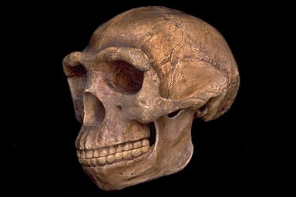

The first evidence of farming – agricultural communities – in China comes from around 7000BC in a place called ‘Jiahu’ in the Central Yellow River Valley. It was discovered in 1962, and even though only about 5% of it has been excavated, archaeologists have uncovered 45 house foundations, 370 cellars, nine pottery kilns, 300 burials and thousands of other artifacts.

Two of the most amazing discoveries are early writing, and playable flutes!

The writing looks remarkably similar to some of the modern Chinese characters today:

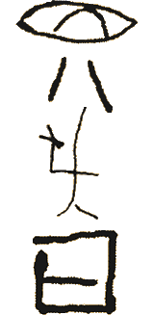

The flutes are made from the wing bones of cranes, and have a scale similar to the eight-note do-re-mi that we have today.

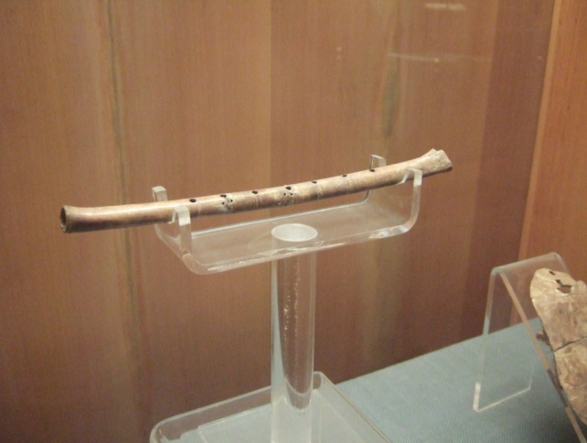

Here is a recording of one of the flutes being played. Remember that this flute is over 9000 years old! To put it on context, do you remember when the pyramids were built?

http://www.bnl.gov/bnlweb/pubaf/pr/1999/Flute7.wav

Later, the Yellow River Valley began to establish itself as a cultural centre, with large villages: one of the most important of which was at Xi’an.

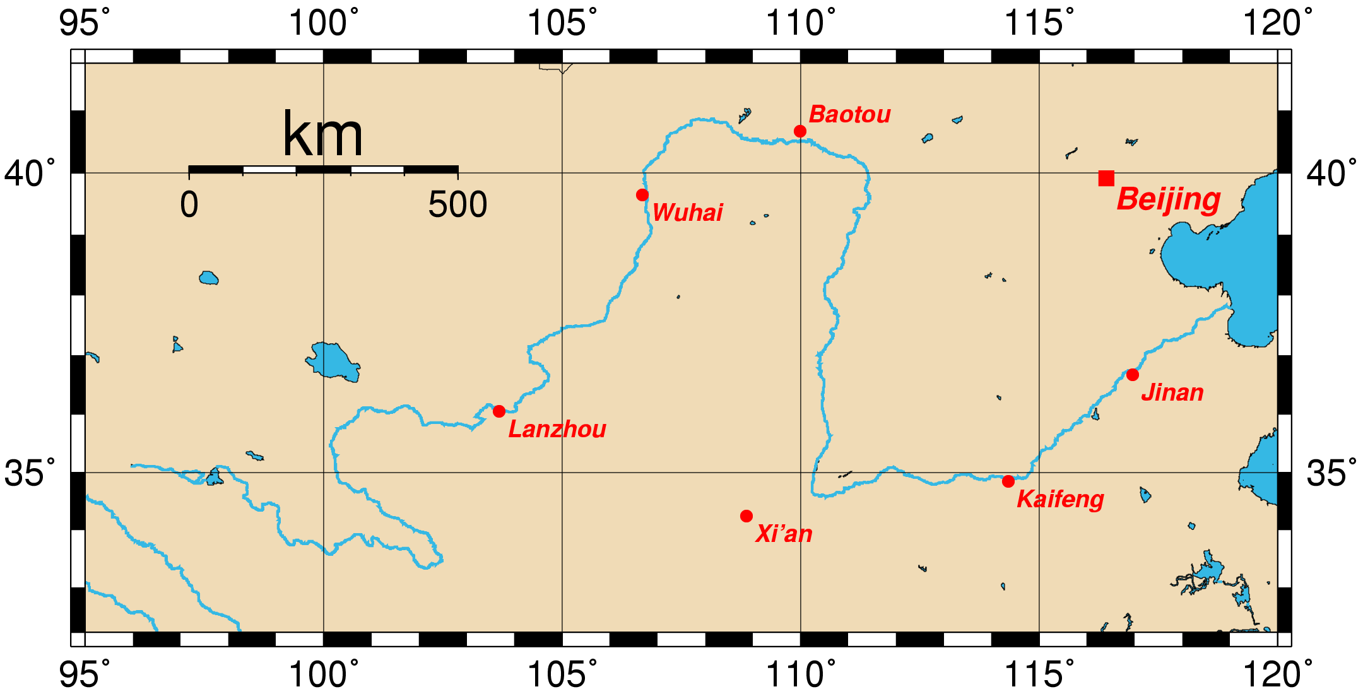

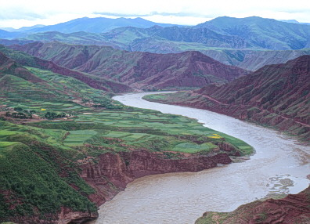
CHINA: THE BEGINNING ACTIVITIES

Answer all of these questions, using the information you have just read to help.

- Generally speaking, where were the first large communities in China located?
___________________________________________________________________________
___________________________________________________________________________
___________________________________________________________________________

- Why were they found there?
___________________________________________________________________________
___________________________________________________________________________
___________________________________________________________________________
___________________________________________________________________________
___________________________________________________________________________

- Why was the Huang He called the ‘Yellow River’?
___________________________________________________________________________
___________________________________________________________________________
___________________________________________________________________________
___________________________________________________________________________

- Give one reason why the Huang He was called China’s blessing, and one reason why it was called China’s curse.
___________________________________________________________________________
___________________________________________________________________________
___________________________________________________________________________
___________________________________________________________________________
___________________________________________________________________________

NATURAL BARRIERS

- Identify the natural barriers that kept China separate from the rest of the world.
  - North:
  - South:
  - East:
  - West:
- Now mark each of them on the satellite image below.
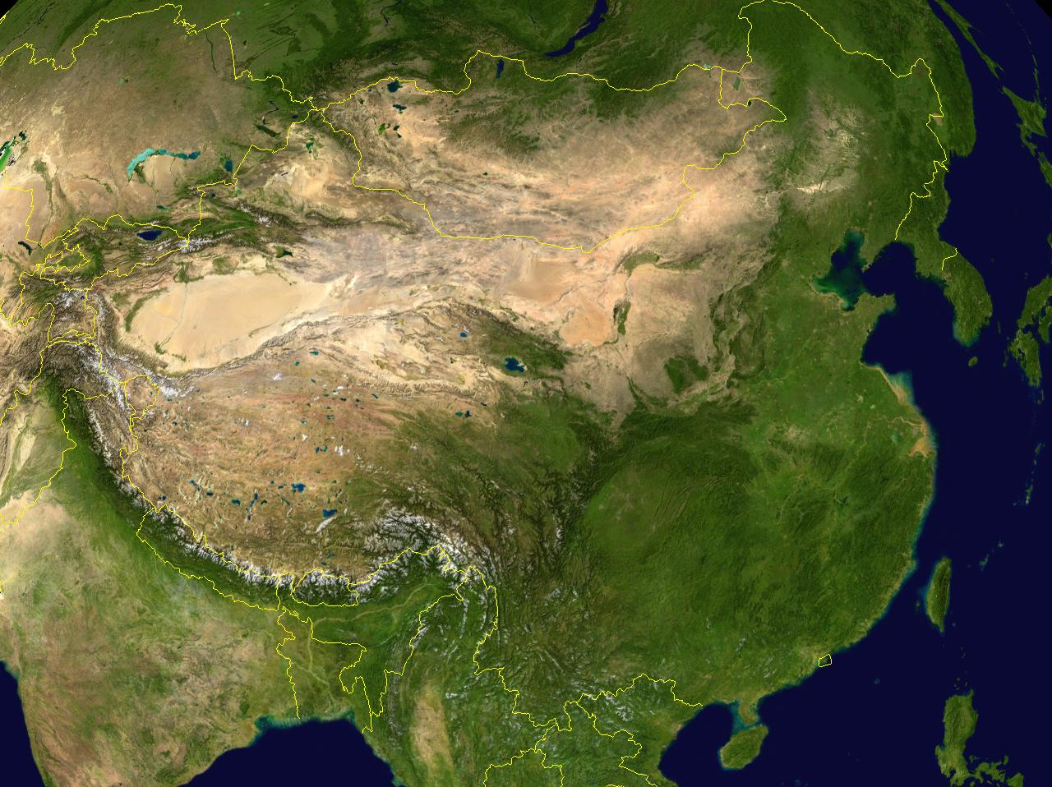
- What effect did isolation have on China’s culture and development?
___________________________________________________________________________
___________________________________________________________________________
___________________________________________________________________________
___________________________________________________________________________
___________________________________________________________________________
- What do the Chinese call their country?
___________________________________________________________________________
- Why do you think they have this opinion?
___________________________________________________________________________
___________________________________________________________________________
___________________________________________________________________________
___________________________________________________________________________

