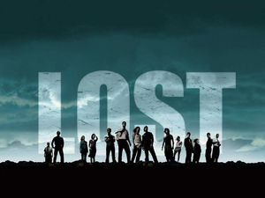
‘LOST’

Watch the opening scene from J.J. Abrams’ ‘Lost.’ Record the details below:

Setting

Time Place

Atmospheric Qualities

Mood Established

Assignment:

Using first person or third person perspective, write a 1-1.5 page descriptive paragraph inspired by one of the characters’ experiences.

Be sure to:
- Use lots of adjectives and adverbs
- Consider all he senses: sights, smells, physical feelings, sounds etc.
- What is the character thinking?

